Application of Exhibition on IP + Optical Network (iPOP 2018)
Date of application
Company Name
Responsible person for exhibition | Name
 | Job title
 | Organization
 | Address
 | Phone
 | FAX
 | E-mail
 | Mobile Phone
Representative participating in exhibition | Name
 | Job title
 | Organization
 | Address
 | Phone
 | FAX
 | E-mail
 | Mobile Phone
Forms must be filled to process your application
(1) Title of your exhibition

(2) Equipment of your exhibition

(3) Space and Layout of your booth
Please choose one of the following members for the exhibition. Each member will be given an appropriate space (The width may change later.)
□ Platinum member (Booth Size : W4.8m x D1.8m, Fee : JPY 500,000)
□ Gold member (Booth Size : W3.6m x D1.8m, Fee : JPY 300,000)
□ Silver member (Booth Size : W2.4m x D1.8m, Fee : JPY 200,000)
□ Bronze member (Booth Size : W1.2m x D1.8m, Fee : JPY 150,000)
- You can request 2 booths if you want a wider space
- JPY 100 (100 Japanese Yen) ＝ ＄0.93 (0.93 US Dollar) as of Mar. 14, 2018.
- One desk and one board will be available free of charge. Platinum member will be available Two desks and two boards. The PC must be prepared by exhibitors.
- Please see (5) and (6) about Business Session and Show Case Demo, respectively.
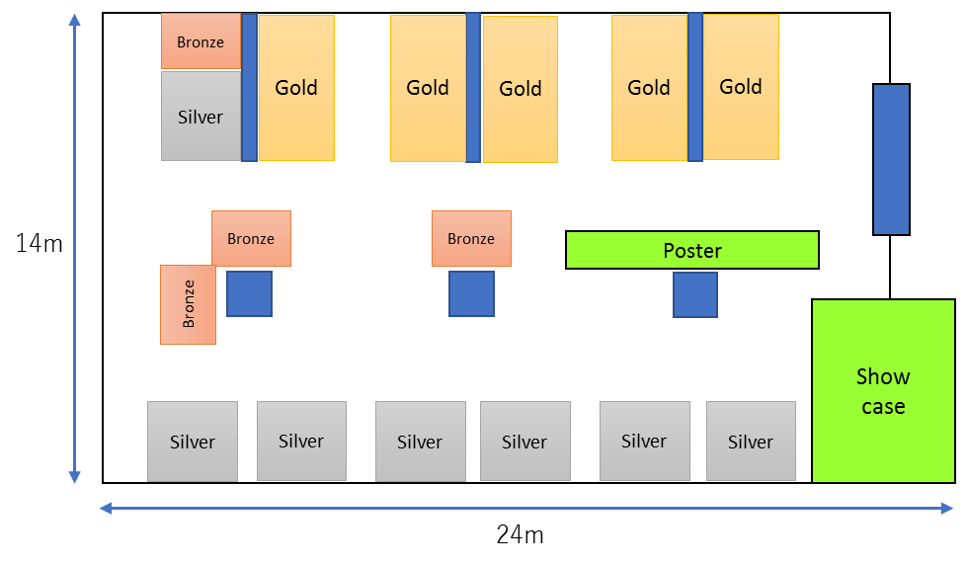
Booth Layout (Tentative)

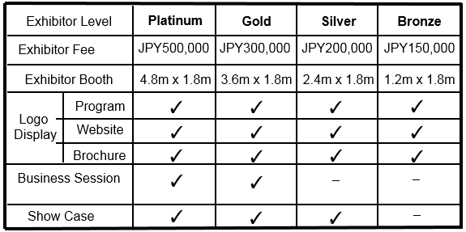
*The Exhibitor Booth might be changed.

(4) Requested capacity of power supply :
circuits of 5 ampere at 100 V (The maximum number of circuits per Booth has not yet been decided.)
Notice: Request may not be met due to the limitation of facility. When we have NOT enough power supply for all members, Platinum, Gold and Silver members have priority. 200V and 48V power supply won’t be provided for the exhibition.
(5) Question about Business Session (for Platinum/Gold member Only)
Do you request a Business Session? Yes / No
- We will send an application form of Business Session later if your answer is “Yes”
- You can speak on business issues such as products, trends, strategies.
- We plan to prepare around 20 minutes per presentation in May 31 (Thu.).
- We may decline your request due to time limitation.
(6) Question about Showcase Demo Space (for Platinum/Gold/Silver member Only)
Do you request in Showcase Demo Space? Yes / No
- We will send an application form of Showcase demo space later if your answer is “Yes”
- At the Showcase Booth, we plan to exhibit related to the technologies below.
SDN/NFV, Data analytics-based monitoring, Streaming telemetry, Containerization, Beyond 100G
transmission, Network resiliency, etc.
- If you are interested in and can exhibit something at the Showcase Booth, please let us know your willingness to exhibit and what kinds of equipment you can exhibit by March 30 (Fri.) to ipop2018-exhibition@pilab.jp
(7) Total Exhibit Fee:
(a) Booth space (select one):
Platinum: JPY 500,000, Gold: JPY 300,000, Silver: JPY 200,000, Bronze: JPY 150,000
(b) Number of booth:
Total fee ( (a) x (b) ) = JPY

(8) About the Internet access:
You can use only a FREE Wi-Fi service in the exhibition room.
Do you request a FREE Wi-Fi service? Yes / No

(9) You are required to send the Logo of your institution with high resolution when you will apply for an exhibition booth.

(10) Your other comments or questions to us

(11) Important notices for Booth, Showcase Demo
Please read the following statements and agree to them before sending this application
- Exhibition will be held on May 31-June 1, 2018. You can prepare for the exhibition on either May 30 (2:30pm to 5:30pm) or May 31 (9:30am to 12:00pm), and you can remove your equipment from your booth after 3:00pm (by 5:30pm) on June 1. After receiving your application, we will take a questionnaire about the equipment to be delivered and carrying-in method. After that, we will inform you about assigning loading and unloading time.
- Expenses for the exhibition will fall on participants. Expenses for preparing exhibition will fall on participants if iPOP will discontinue.
- You are responsible for carrying, setting up and removing your equipment. We are not responsible for the robbery, loss or breakdown of your equipment, accident, and acts of God.
- We will decide layouts of the exhibition hall respecting for all applicants’ requests. However we may decline your application if we don’t have enough space in the exhibition hall.
- Please take care of your exhibition not to obstruct the other participants’ exhibition if you use the sound for your exhibition.
- We will send you a formal application form, a layout of the exhibition hall and a detailed schedule for the exhibition later.
- Please provide an electronic file of posters you will present on your booth. We will make it can download available from the iPOP 2018 WEB.
Contact
iPOP exhibition office : ipop2018-exhibition@pilab.jp

closing date for showcase subscription
March 30, 2018.
closing date for exhibition subscription
March 30, 2018.

About the iPOP 2018
https://www.pilab.jp/ipop2018/index.php

Holding record of the iPOP 2017
https://www.pilab.jp/ipop2017/
https://www.pilab.jp/ipop2017/archives/exhibition.html

Applicant does not need to fill in the following. It will be filled by iPOP exhibition office.
Date of receipt |  | Receipt No.

